Sprint 3 Plan - CSE 115a – Intro to Software Engineering

Goal
At this point in the project, we have a basic web app with both the frontend and backend connected and running. We are able to connect our Spotify account, view the playlists, and get basic information. In this sprint, our main focus is to start adding different features and making sure they are integrated and working together properly.

Tasks
User Story 1 (“As a user, I want to be able to find an individual price to a song”)
- Task 1: Finish connecting Discogs script to front end (2 hours)
- Task 2: Create access tool to allow user to focus on an individual song (1 hour)
- Task 3: Create a method that pulls the cost of an individual song (2 hours)
- Task 4: Create a page that automatically displays the song, album cover, and price (1 hour)
- Total: 6 hours
User Story 2 (“As a user, I want to be able to learn how much my playlists cost”)
- Task 1: Have a method that uses user story 1’s method and compiles all the songs of the playlist (1 hour)
- Task 2: Modify the playlist page of the web app to automatically display the total cost (30 minutes)
- Total: 1.5 hours
User Story 3 (“As a user, I want to be able to be able to retrieve a link for at least one song”)
- Task 1: Create an access tool for the user to request a link (30 minutes)
- Task 2: Connect the access tool to both the playlist display page and the song display page (30 minutes)
- Task 3: Create a method that takes a songs name/album and returns the link (1.5 hours)
- Task 4: Create a page that pulls the information and displays the best options (top 5) from cheapest to most expensive (2 hours)
- Total: 4.5 hours
User Story 4 (“As a user, I want to be able to choose the format for the physical media”)
- Task 1: Create a button/access tool for choosing format (30 minutes)
- Task 2: Create a page with the different available options -> modify from the top 5 method in user story 3 (1 hour)
- Task 3: Create/Modify a method that searches discogs, and handles the different edge cases and returns/displays errors if not possible (4 hours)
- Total: 5.5 hours

Team Roles
- Richard - Product Owner {Developer}
- Vanessa - Scrum Master {Developer}
- Kaan - Developer
- Victor - Developer
- Abner - Developer

Initial Task Assignment
- Richard - User Story 1 - Task 1
- Vanessa - User Story 1 - Task 3
- Kaan - User Story 1 - Task 4
- Victor - User Story 1 - Task 2
- Abner - User Story 3 - Task 3

Initial Burnup Chart
// to include

Initial Scrum Board
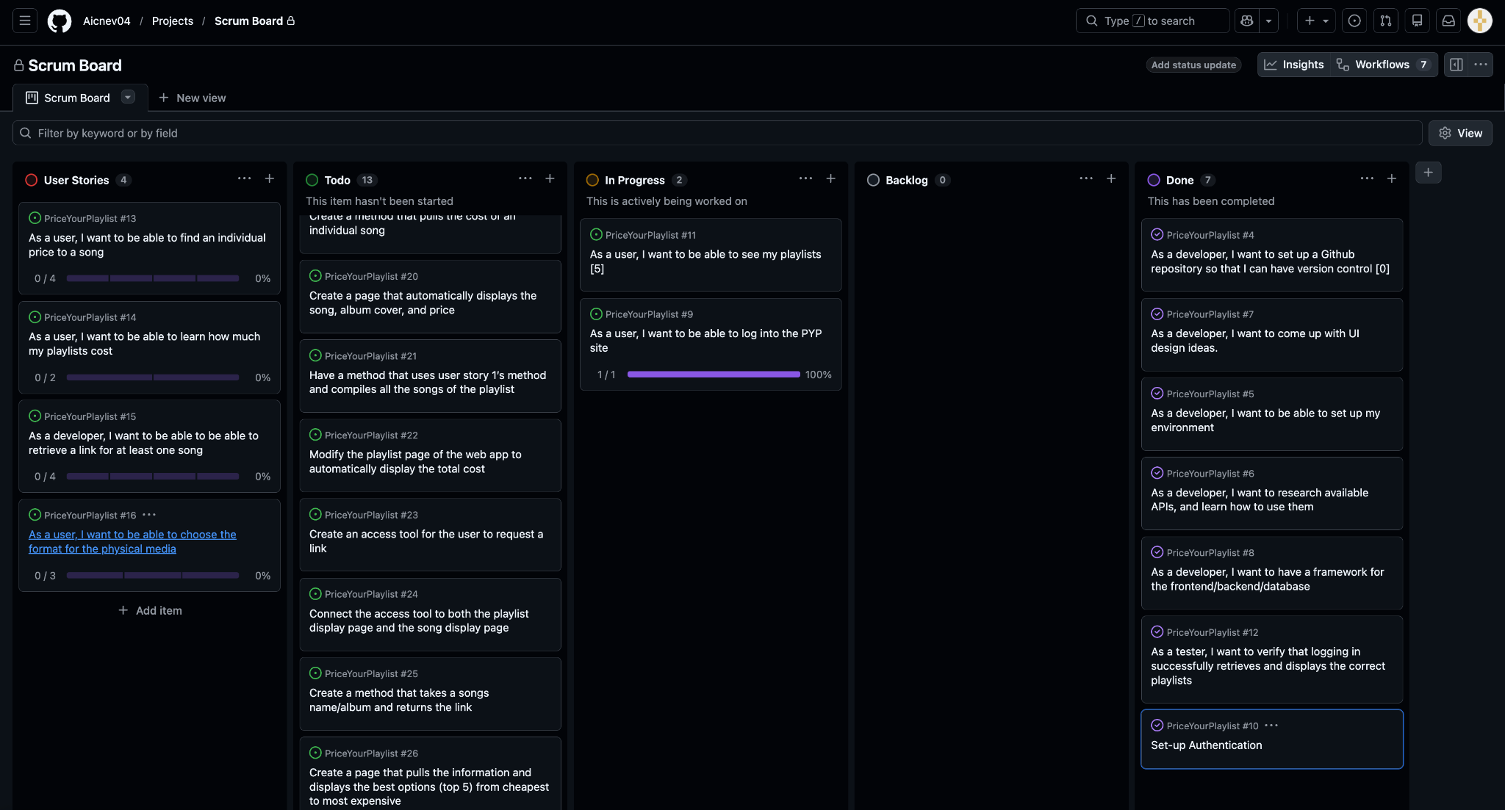

Scrum Times
- Tuesday 5/5 - 4pm - Group Meeting
- Wednesday 5/6 - 11:30am - TA Meeting
- Thursday 5/7 - 4pm - Group Meeting
- Tuesday 5/12 - 4pm - Group Meeting
- Wednesday 5/13 - 11:30am - TA Meeting
- Thursday 5/14 - 4pm - Group Meeting

